



**Objective:**

The primary goal of environmental monitoring in parks is to assess and track the condition of the park's natural resources and ecosystems.It aims to detect changes in environmental factors, such as air and water quality, wildlife populations, vegetation health, and climate patterns.

**Vision:**

Our vision for environmental monitoring in parks is to create a harmonious and sustainable coexistence between nature, recreation, and conservation. We aim to transform parks into living laboratories where cutting-edge technology and community engagement converge to safeguard the environment and enhance the visitor experience.

**Problem Statement:**

Parks are valuable public spaces for relaxation and outdoor activities, attracting a diverse range of visitors throughout the year. However, fluctuating environmental conditions, particularly temperature and humidity, can significantly impact visitors' comfort and experience. The challenge is to create an IoT-based environmental monitoring system that ensures optimal temperature and humidity levels in park areas, enhancing visitor satisfaction and well-being.

**Problem Description:**

**Extreme Weather Conditions:**  Parks often experience a wide range of temperatures and humidity levels due to seasonal variations. Extreme heat or cold can make park visits uncomfortable or even unsafe for visitors.

**Visitor Experience:** Unfavourable environmental conditions can deter visitors from enjoying the park's natural beauty and amenities, affecting their overall experience.

**Health Concerns:**  Extreme temperatures can pose health risks, such as heat exhaustion or hypothermia, especially for vulnerable populations like children and the elderly.

**Resource Management:** Inefficient use of resources, such as heating and cooling systems in park facilities, can lead to unnecessary energy consumption and environmental impact.

**Solution for an IoT-Based Temperature and Humidity Environmental Monitoring Project in Parks:**

**1. Sensor Deployment:** Install a network of temperature and humidity sensors strategically across various park zones, ensuring comprehensive coverage of visitor areas, facilities, and natural spaces.

**2. Data Collection and Analysis:** Collect data from the deployed sensors in real-time and transmit it to a centralized database or cloud platform. Utilize advanced data analytics techniques, including machine learning algorithms, to process and analyze the data efficiently.

**3. Automated Control System:** Implement an automated control system that can adjust environmental conditions in park facilities based on the real-time data. For instance, when the temperature rises significantly in a park pavilion, the system can activate cooling mechanisms to maintain a comfortable environment for visitors.

**4. Alerts and Notifications:** Develop an alert system that can notify park management and staff when extreme conditions are detected, enabling swift response to visitor safety concerns.

**5. Visitor Information Access:** Create a user-friendly mobile application or integrate data displays in the park's visitor centers to provide real-time temperature and humid

ity information. Include weather forecasts and tips for visitors to prepare accordingly.

**6. Energy Efficiency:** Ensure the control system is designed for energy efficiency, optimizing heating, cooling, and ventilation systems to minimize resource consumption.

**7. Data Visualization:** Visualize temperature and humidity data on interactive maps or graphs, allowing park management to identify trends and areas that frequently require adjustments.

**8. Visitor Education:** Incorporate educational content in the mobile app, explaining the importance of environmental comfort and how responsible resource use benefits both visitors and the environment.

**9. Regular Maintenance:** Establish a routine maintenance schedule for sensors and control systems to ensure accuracy and reliability. Implement fail-safe mechanisms to address sensor malfunctions promptly.

**10. Feedback Loop:** Encourage park visitors to provide feedback through the app or on-site kiosks regarding their comfort and experience. This feedback can help in continuous improvement.

**11. Data Security and Privacy:** Prioritize data security and privacy to protect sensitive information collected from park visitors.

**12. Accessibility:** Ensure that temperature and humidity information is accessible to all visitors, including those with disabilities, through inclusive design practices.

By implementing these solutions, the IoT-based environmental monitoring system will not only enhance visitor comfort and safety in parks but also contribute to responsible resource management, making parks more enjoyable and sustainable for all.

**Design Framework:**

In this project, we are going to send Temperature and Humidity sensor data to Thingspeak using DHT11. By this method, we can monitor our DHT11 sensor’s temperature and humidity data over the internet using the ThingSpeak IoT server, and we can view the logged data and graph over time on the ThingSpeak dashboard. NodeMCU reads the current temperature and humidity from DHT11 and sends it to the ThingSpeak server for live monitoring from anywhere in the world.

**Components Required:**

* NodeMCU
* DHT11 Temperature and Humidity Sensor
* Jumper Wires
* Breadboard

**Features of the components:**

**NodeMCU:**

* Based on ESP8266 Wi-Fi module.
* Built-in Wi-Fi connectivity. Supports Lua scripting and Arduino IDE. GPIO pins for digital I/O and PWM.
* Analog input pins.
* UART, SPI, and I2C communication support.
* USB-to-Serial interface for programming.
* Low power consumption for battery-powered devices.
* Over-the-Air (OTA) firmware updates.
* Active and supportive community.
* Affordable for hobbyists and developers.

**DHT11 Temperature and Humidity Sensor:**

* Combined temperature and humidity sensing.
* Digital output for easy interfacing with microcontrollers.
* Low cost and widely available.
* Reliable for basic temperature and humidity monitoring.
* Limited accuracy and range compared to more advanced sensors.
* Single-wire communication protocol.

**IOT Device Developments:**

**Circuit Diagram:**

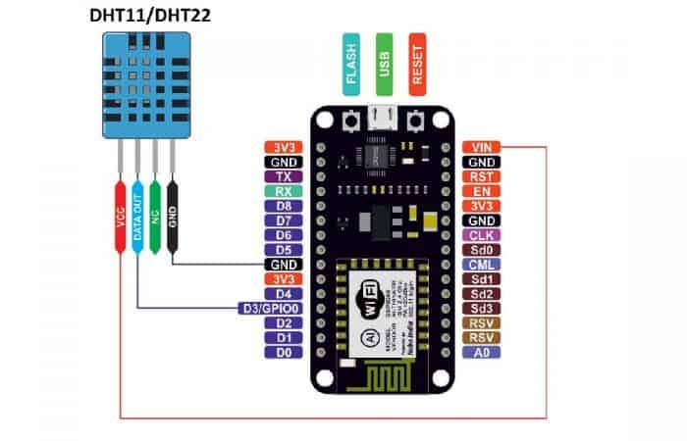

**DHT11 Humidity & Temperature Sensor:**

The DHT11 is a basic, ultra low-cost digital temperature and humidity sensor. It uses a capacitive humidity sensor and a thermistor to measure the surrounding air and spits out a digital signal on the data pin (no analog input pins needed).

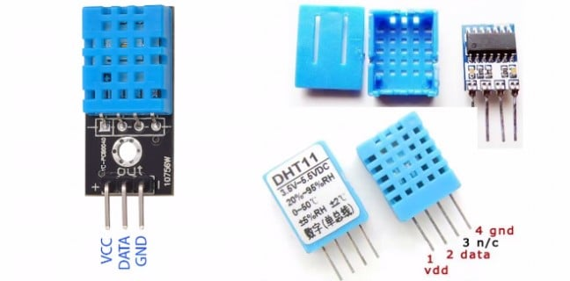

It’s fairly simple to use but requires careful timing to grab data. The only real downside of this sensor is you can only get new data from it once every 2 seconds, so when using the library, sensor readings can be up to 2 seconds old.

**Benefits:**

**1. Data Collection and Analysis:** IoT sensors can monitor various environmental parameters like air quality, temperature, humidity, water quality, and more. This data helps park authorities to understand the ecosystem's health and make informed decisions.

**2. Wildlife Conservation: I**oT can track the movement of animals within the park, helping researchers gather data on their behavior and migration patterns. This information is vital for wildlife conservation efforts.

**3. Weather Monitoring:** Real-time weather data collected through IoT sensors can assist park management in predicting and preparing for extreme weather events, ensuring visitor safety.

**4. Fire Detection:** IoT sensors can detect sudden increases in temperature or the presence of smoke, enabling early wildfire detection and rapid response.

**5. Water Management:** IoT devices can monitor water sources within the park, helping to manage water levels, quality, and ensure the sustainability of aquatic ecosystems.

**6. Visitor Experience:** IoT can enhance the visitor experience by providing real-time information on trail conditions, parking availability, and even guided tours using mobile apps.

**7. Energy Efficiency:** Smart lighting and heating/cooling systems can reduce energy consumption in park facilities, contributing to sustainability goals.

**8. Noise Pollution Monitoring:** Sensors can measure noise levels and help manage noise pollution in the park, preserving the natural soundscape.

**9. Ecosystem Research:** IoT data can support scientific research within the park, aiding in ecological studies and climate change research.

**10. Remote Monitoring:** Park managers can the need for physical inspections and saving resources.

**Conclusion:**

The implementation of IoT (Internet of Things) technology for environmental monitoring in parks holds immense potential for advancing our understanding of these vital natural spaces. By leveraging IoT sensors, data analytics, and real-time connectivity, we can transform parks into smarter, more resilient ecosystems.

This innovation not only enhances our ability to protect and conserve these natural wonders but also enriches the park experience for visitors. Through the power of data and technology, we can foster a deeper connection between people and nature.

As we move forward in embracing IoT for environmental monitoring in parks, we look forward to collaboration, investment, and partnerships that will help us turn this vision into a reality. Together, we can create a brighter, more sustainable future for our parks, benefiting both current and future generations.